

Machine Learning Foundations
Professor Prashanth L A
Department of Computer Science and Engineering
Indian Institute of Technology, Madras
Orthogonal Vectors and Subspaces
Welcome to the second lecture in week 3 of Machine Learning Foundations. In this lecture we will understand the concept of orthogonality and orthogonal subspaces. The buildup for the idea is that once we understand orthogonality and orthogonal complements we will be able to understand what one means by doing orthogonal projections, which is coming in the follow-up lecture.
And these two will lead up to understanding least squares problems, which is; least squares problems which are closely tied to projections, understanding projections. So, in this lecture we will understand what it means when we say two vectors are orthogonal and what does it mean to say two subspaces are orthogonal.
And we will also characterize orthogonal subspaces, I mean we will take the four fundamental subspaces we had earlier which is the column, null space, row space and left null space. And try to understand which vector in which space is orthogonal to which other vector in another subspace, so which subspace is orthogonal to the other in terms of the four fundamental subspaces that is something that we will understand in this lecture.
(Refer Slide Time: 1:26)
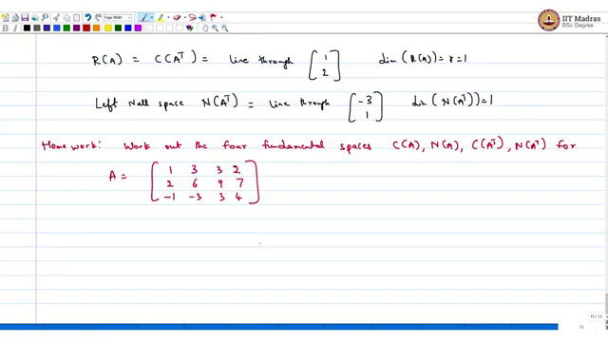
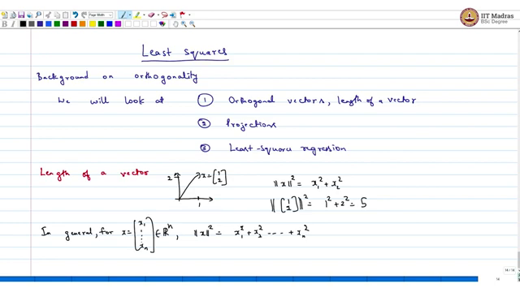
Now, I needed these four subspaces simply because I wanted to move on to the very new topic which is, I mean, build up is to solve look at least squares and for this I need to cover background material on orthogonality which is what I will do and then look at projections, so the idea is to look at what it means, so coming next, so what we are going to look at, we will look at 1 orthogonal vectors, length of a vector.
2, we look at projections and then this leads to least squares problem. This is what we will get to, so this is the order we will look at, we will start with orthogonality, I mean, what it means to be a length of a vector, this is something I must have looked at before, we are doing a quick recap, let us say, imagine you have some vector 1 and 2, so this is the vector 1 , 2, that I have drawn to the best of my abilities.
So, what is the length of this? What we do is x 1 square + x 2 square, which in this case, so square = 1 square + 2 square = 5. So, that is the intuitive notion of a length. So, in general if you have a x belonging to Rn, for x belonging to Rn the length of x is defined like this, for x = x1 until xn belonging to Rn, this is the length.
(Refer Slide Time: 5:16)
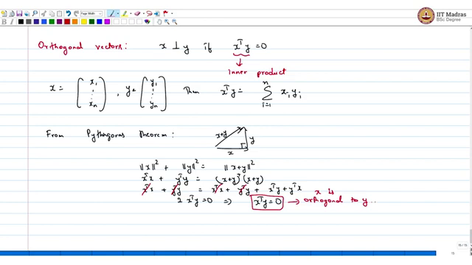
Now the next notion is when are two vectors orthogonal? Orthogonal vectors we can say that x is orthogonal to y, if x transpose y = 0, here this is called the inner product or dot product in some books. So, if x = x 1 up till xn, y = y 1 up till yn, then x transpose y is summation xi yi = 1 to n. Now, this definition coincides with our notion of a right angle triangle or Pythagoras theorem, so recall what you have from Pythagoras theorem.
From Pythagoras theorem, if you have a right angle triangle say x y, x + y, so this notion of right angle is that this + this = x + y square. Now, if you expand this using our definition this is the same as x transpose x + y transpose y = x + y transpose x + y, which is the same as x transpose x + y transpose y + x transpose y + y transpose x, this goes off, so you get 2 × x transpose y = 0 in place x transpose y = 0, this is the same as saying orthogonal, x is orthogonal to y.
(Refer Slide Time: 8:20)
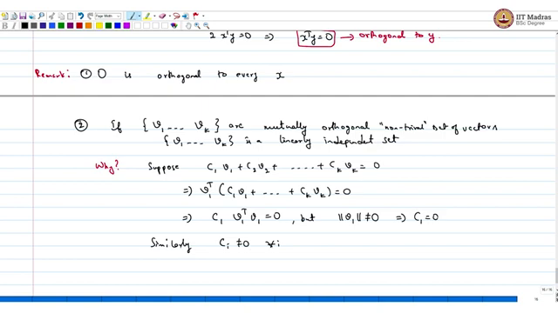
Just a quick remark, 0 is orthogonal to every x, first claim. The second one is if the vectors v 1 to v k are mutually orthogonal then is a linearly independent set. I mean, this is easy to show, why, I mean let us see why, simply because, let suppose some linear combination of this vectors leads to 0, say c 1, v 1 + c 2, v 2 + c k, v k = 0, now if I take the dot product with v 1 on both sides, we get 0.
This implies c 1 into v 1 transpose v 1 = 0, but it is not 0 implies c 1 = 0. Similarly, c i not equal to 0 for all i. Let me put it like this mutually orthogonal non-trivial set of vectors. So, these are not the 0 vectors, so assuming 0 is not part of this, so then we get this, that is the end of this claim. You can just look at a quick example about.
(Refer Slide Time: 10:53)
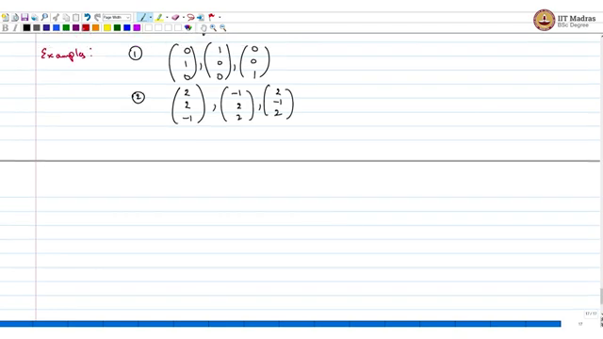
Example: The standard basis say 0, 1, 0, 1, 0, 0, 0, 0, 1, these are orthogonal vectors. It need not be standard; you can make up other examples also, for example, this 2, 2, 2, -1, 2.
(Refer Slide Time: 11:58)
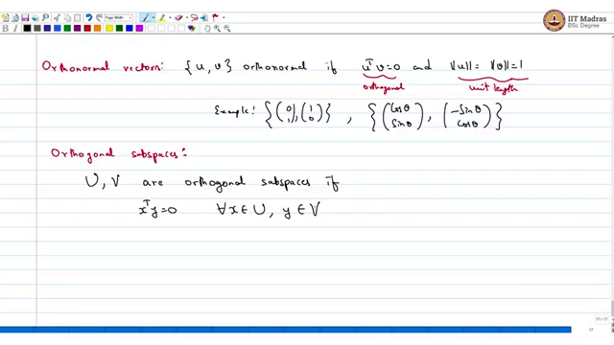
Now, we have another related concept called orthonormal vectors, which is orthonormal u , v orthonormal if they are orthogonal and of unit length. So, this is orthogonal, this is unit length. So, again an example is 0 1, 1 0; another example is say, cos theta, sin theta - sin theta cos theta these are two examples. Now, once we have defined orthonormal vectors orthogonality, we can also look at what is called orthogonal subspaces.
So, if you have two subspaces u , v, so I am going to use capital letters for subspaces, small letters for vectors. So, U , V are orthogonal subspaces if x transpose y = 0. So, if I take anything from U and any other vector from V and if I take the dot product it has to 0; this is like for all x belonging to U and for all y belonging to V.
(Refer Slide Time: 14:05)
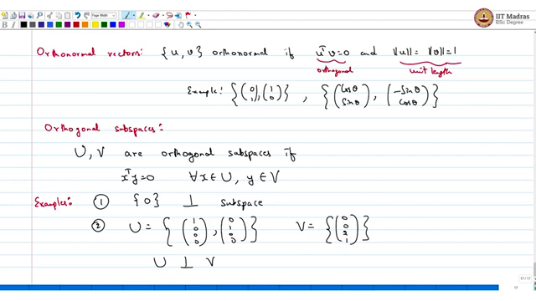
Now, again we can look at some examples. The first example obvious trivial example is take vector 0 it is orthogonal to every subspace that you can think of, so define another, so define U is, as the span of 1, 0, 0, 0, and say 0, 1, 0, 0 suppose this is U and then say V is something else, say 0, 0 you take the last two coordinates, then U is orthogonal. I mean, V is not the only orthogonal subspace of U, U could make up another one.
(Refer Slide Time: 15:31)
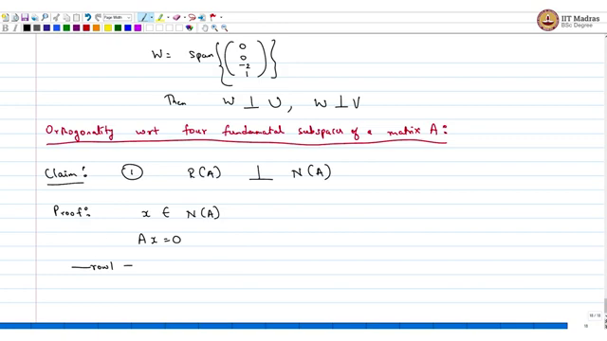
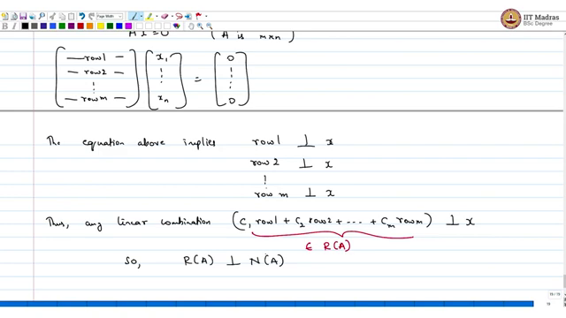
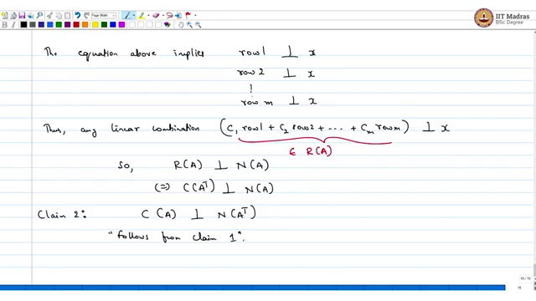
If I write say W = span of 0, 0 - 2, 1, then W is orthogonal to U and W is orthogonal to V. Orthogonality with respect to the four fundamental subspaces of a matrix. So, the first claim is if I take the row space of A then it is orthogonal to the null space of A and the proof is fairly straight forward, if I take x belonging to null space of A, then it just means that Ax = 0, which is like writing say row 1, keep running out of space.
So, A is m ×ing n, a is m × n unless specify explicitly, it is a square matrix, assume it is some m × n matrix, so you have row 1, row 2, until row m, this is A and then you have x 1 until xn, this is the 0 vector. The equation above implies row 1 is orthogonal to x and row 2 is also orthogonal to x and so on until row m is orthogonal to x. That is amply clear because you are taking a dot product here, do not know how to highlight.
If you take the dot product here, so row, then what you are getting is 0. So, row 1 is orthogonal to x, if I take row 1 dot product with x, then I am getting 0, so row one is orthogonal to x, similarly row 2 is orthogonal to x and row m is orthogonal to x. Then thus, any linear combination say c 1 row 1 + c 2 row 2 and so on + c m row m, this will be orthogonal to x and this belongs to the row space of A.
So, if I take the row space of A, it is orthogonal to null space of k, which is the same as writing or equivalently colon space of A transpose is orthogonal to null space of A. Now, the same thing can be written like this column space of A is orthogonal to null space of A transpose. You could do a much shorter proof; I am going to skip the proof, follows from claim 1.
(Refer Slide Time: 20:31)
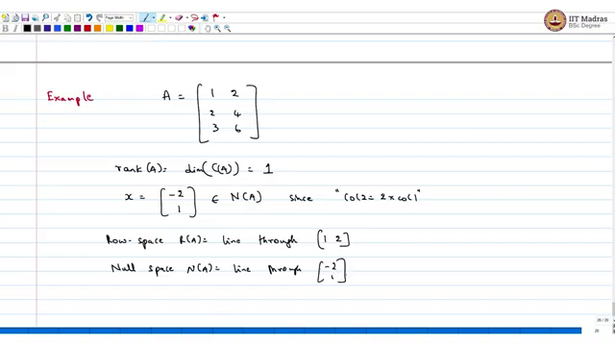
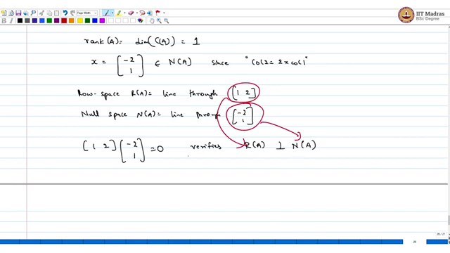
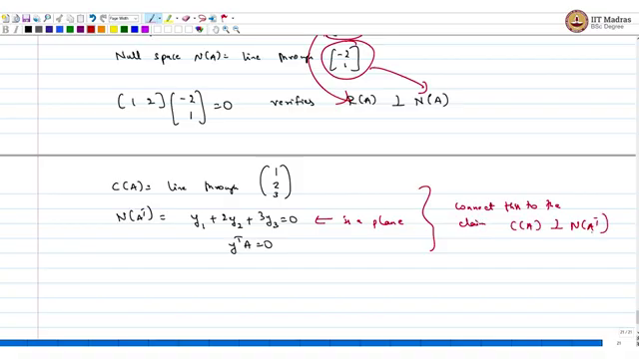
Let us look at an example and in this discussion again. So, what is the rank of A which is the dimension of column space of A, it is obvious that the second column is just two × first column, so the dimension of the column space of A is 1 and if you want to look at what would be an entry belonging to the null space. So, if I set x = - 2 , 1, then this belongs to null space, it is fairly simple.
Take - 2 × the first column and 1 × the second column that results in the, since column 2 = two × column 1. Now again we can look at the row space R of A is just the line through, you look at each row, first row is 1, 2, second row is two × the first row, third row is three × the first row, so this is really one row that matters, the other rows are just scalar multiples of the other row, first row.
So, the row space is just the line through 1, 2 and null space N of A is the line through - 2, 1. Now if I take, now if I look at 1, 2 and 2 - 2 , 1 this is equal to 0, and that is just, this verifies row space of A is orthogonal to null space of A, because I took an entry here, and 1, 2 belongs here. So, I took an entry from the row space of A, a vector, and I took another vector from the null space and their dot product led to 0, so they are orthogonal.
You could check this even for the other two spaces, so if I look at column space of A it is just the line through 1, 2, 3, and then the null space of A transpose, the set of all Y's such that y 1 + 2 y 2 + 3 y 3 = 0 and this is not a line, this is a plane. And why this is true, this is set of all y transpose A = 0 and this y transpose A = 0 is the same as column space of A is orthogonal to null space of A transpose. So, think about this, so connect this to the claim column space of A is orthogonal to null space of A transpose.
(Refer Slide Time: 25:20)
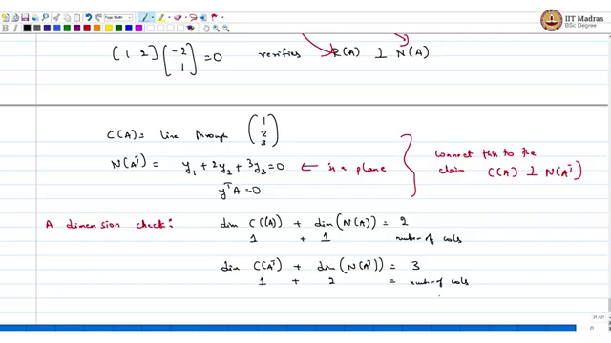
We could check the dimensions, dimension check, dimension of colon space of A transpose + dimension of, this should be 2, so this is the number of columns, this is the number of columns and this is 1 and this is 1. Now, dimension of column space of A transpose + dimension of null space of A transpose, this should be the number of rows which is 3, and this we know is 1 this we know is 2, this is the number of columns. That is where we will end this lecture. We will next look at projections.
So, before we end this lecture we will have a brief recap. What we learned in this lecture first and foremost is the simple concept of length of a vector that is something we learned and then we understood what it means to say two vectors are orthogonal and we also understood what it means to say one subspace is orthogonal to another.
And using this notion of orthogonal subspaces we were able to understand the four fundamental subspaces as well; in particular we were able to show that if I take the row space, any vector in the row space then it is orthogonal to any vector in the null space of a given matrix, so these two subspaces are orthogonal. Along similar lines we were also able to show that any vector in the column space of a matrix is orthogonal to any vector in the left null space of the same matrix.
And, so we understood this, we were able to show these two claims and also we worked out these four subspaces and also understood that by characterizing the basis we were able to infer that the two claims that I just said which is the row space is orthogonal to the null space, and the second claim which was column space is orthogonal to the left null space. We were able to verify this through an example. In the next lecture we will be looking at projections and that will lead up to the least squares problem subsequently.

